EXPERIMENT - 6
NAME: PERIYA NAYAGAM M ROLL NO: 240701382
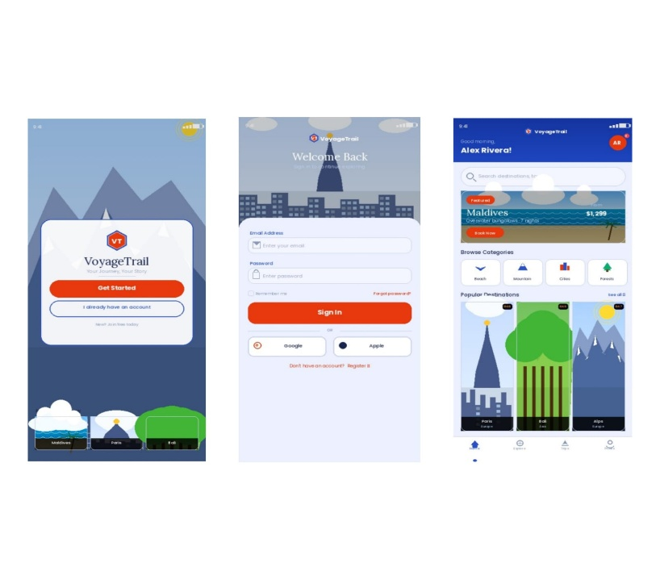
App Name
Voyage Trail (Travel App UI Design)

Light Mode Design
Description
Light mode is a user interface design where:
- Background is light (white / light blue)
- Text is dark for better readability
Characteristics
- Easy to read in daylight
- Clean and minimal appearance
- User-friendly for long usage
- Commonly used as default mode

Screens Designed
- Welcome Screen
- Login Screen
- Dashboard Screen

Design Details
- Background Colour: Light Blue
- Text Colour: Dark Blue / Black
- Buttons: Orange / Dark Blue
- Theme Feel: Simple, clean, and fresh
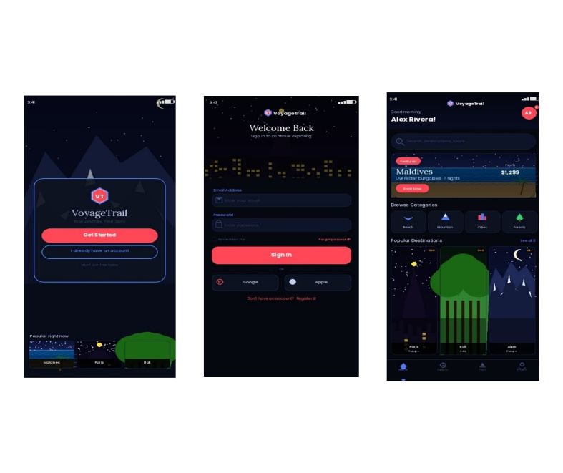
Dark Mode Design
Description
Dark mode is a user interface design where:
- Background is dark
- Text is light-coloured

Characteristics
- Comfortable in low light
- Reduces eye strain
- Saves battery (OLED screens)
- Gives modern and premium look

Screens Designed
- Welcome Screen
- Login Screen
- Dashboard Screen

Design Details
- Background Colour: Dark Blue / Black
- Text Colour: White / Light Blue
- Buttons: Red / Light Blue
- Theme Feel: Attractive, modern, and aesthetic
Inference
- Light mode is more popular among users
- The app design is visually appealing and user-friendly
- Minor improvements can be made in readability and spacing
- Overall, the UI design was successful and well-received

